- Tên và phân loại:

- Mục đích, ý nghĩa:
- Ensure a class only has one instance, and provide a global
point of access to it
- Động lực sử dụng:
- Some classes should have exactly one instance
• One print spooler
• One file system
• One window manager
- A global variable makes an object accessible but doesn‟t
prohibit instantiation of multiple objects
- Class should be responsible for keeping track of its sole
interface
- Khi nào sử dụng:
- There must be exactly one instance of a class, and it must be
accessible to clients from a well-known access point
- This sole instance should be extensible by sub-classing, and clients
should be able to use an extended instance without modifying their
code
- Cấu trúc
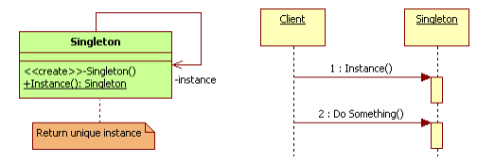
- Các thành viên - Sự cộng tác
- Singleton
• Defines an Instance operation that lets clients access its unique
instance
• Instance is a class operation (that is, a class method and a static
member function) may be responsible for creating its own unique
instance
- Các hệ quả mang lại:
- Controlled access to sole instance
• Because the Singleton class encapsulates its sole instance, it can have
strict control over how and when clients access it
- Reduced name space
• An improvement over global variables
• Avoids polluting the name space with global variables that store sole
instances
- Permits refinement of operations and representation
• The Singleton class may be sub-classed, and it's easy to configure an
application with an instance of this extended class
• You can configure the application with an instance of the class you need
at run-time
- Permits a variable number of instances
• Makes it easy to change your mind and allow more than one instance of
the Singleton class
• Moreover, you can use the same approach to control the number of
instances that the application uses. Only the operation that grants access
to the Singleton instance needs to change
- Chú ý liên quan đến cài đặt:

- Hệ thống thực tế
▪ Win32: GetProcessHeap
▪ MFC: AfxGetApp, AfxGetMainWnd
▪ .NET: System.AppDomain.CurrentDomain

- Mẫu liên quan
- Many patterns can be implemented using the Singleton
pattern
• Abstract Factory
• Builder
• Prototype

